**Php database connection**

The connection is being run through xampp’s localhost.



The first line is connecting to your localhost server. Everyone’s connections will be different. If it is your first time using xampp the password field will be empty, it can be left empty, my own is just changed for past databases, it is not needed.

The second line is to select the database you want from your server. After that the connection is complete, you can test it just to be sure.

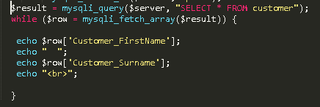

I just did a pull to retrieve and display the full names of our customers to make sure our connection is working.

This can be linked with the javascript file to calculate and save quotes for customers.